<WHATSCAMP>

<User Manual>

Purpose of the document

The purpose of this document is to describe the application WhatsCamp to the user

Contents

Table of Contents

Purpose of the document 1

1. General Description 4

1.1 Brief description 4

1.2 Project players 4

1.3 Support 4

1.4 Address 4

1.5 Authentication 4

1.6 System Requirement 4

2. Structure of the Application 5

2.1 Layout 5

2.2 Menus 5

2.3 Icons / Shortcuts & Buttons 5

2.4 Functionalities 7

2.4.1 Functionalities Presented/Described 7

2.4.2 Functionalities not Presented/not Described 8

3. Functionalities 1 : View/Filter Event 8

3.1 Screenshot 8

3.2 Descriptions of fields, content 10

3.3 Description of actions 10

3.4 Sequence of screens 10

4. Functionalities 2 : Favourite Event 10

4.1 Screenshot 10

4.2 Descriptions of fields, content 11

4.3 Description of actions 11

4.4 Sequence of screens 11

5. Functionalities 3 : Search Event 11

5.1 Screenshot 11

5.2 Description of fields, content 12

5.3 Description of actions 12

5.4 Sequence of screens 12

6. Functionalities 4 : Going to Event 12

6.1 Screenshot 12

6.2 Description of fields, content 13

6.3 Description of actions 13

6.4 Sequence of screens 13

7. Functionalities 5 : Manage Event(Edit, Delete, and Add Event) 13

7.1 Screenshot 13

7.2 Description of fields, content 14

7.3 Description of actions 14

7.4 Sequence of screens 14

8. References 14

# General Description

## Brief description

In a brief, WhatsCamp is application that enables user to search and keep information about events which includes event information, date of the event, participant’s terms and conditions, fee (for several events) and every details that related to the event that the user selected.

## Project players

WhatsCamp is developed by Informatics student at Universitas Pelita Harapan for Human Computer Interaction project.

-Alvin Christianto Callysta, 00000012551

-Cika Desela Putri Marsyaf, 00000011818

-Clarissa Veronica Kusuma, 00000013004

-Jessica Sean, 00000013452

-Joseph, 00000013230

-Keren Angelia Raintung, 00000013347

-Kevin Kurniawan, 00000014200

## Support

You can contact us through [whatscamp.support@gmail.com](mailto:whatscamp.support@gmail.com) for support.

## Address

WhatsCamp does not require internet connection to be accessed.

## Authentication

WhatsCamp requires authentication in order to be used.

## System Requirement

Minimum System Requirement:

1. Android OS: Kitkat (API 19)

2. CPU: 1 Ghz Dual-core

3. RAM: 512 MB

4. Storage: at least 15 MB

5. Permissions: Storage

# Structure of the Application

## Layout

In general, the layout for main activity WhatsCamp is given below:

-Navigation drawer: when clicked, it will show all menus, and extras.

-Top Bar: shows activity title, contains navigation drawer and options menu

|  |  |  |
| --- | --- | --- |
| Navigation Drawer | Top Bar | Function |
| Main Content | | |

-Function: when clicked, it will do an something (depends on which activity).

-Main Content: all the content for apps will be shown here. For the *view event* feature, there is a share button to share event onto another application (facebook, twitter, etc.).

## Menus

Navigation Drawer:

1. Home: goes to home.
2. Categories: all events divided into some categories.
3. Favourites: shows all events that user selected as their favourite.
4. Search: to search events.

Function:

1. Hide Map: to unpublish the event (Edit Event).
2. Add Events (+ icon): to add events (Manage Event).

## Icons / Shortcuts & Buttons

|  |  |
| --- | --- |
| **Icon** | **Function** |
|  | App’s launcher icon. [1] |
|  | Menu icons, display all main features. [1] |
|  | Shortcut to Home (main page). [1] |
|  | To go to Event Categories. [1] |
|  | Click this icon to set event as favourite, or to view. [1] |
|  | To search events. [1] |
|  | To show information about the apps and the developer. [1] |
|  | To show terms and conditions. [1] |
|  | To go to app’s settings. [1] |
|  | To log on to the apps. [1] |
|  | To show user’s profile. [1] |
|  | To show user’s event. [1] |
|  | To add event. [1] |
|  | To back to previous activity. [1] |

|  |  |
| --- | --- |
| **Button** | **Function** |
|  | To share current event to another apps or platforms. [2] |
|  | To share the event to facebook. [2] |
|  | To share the event to google +. [2] |
|  | To share the event to email. [2] |
|  | To share the event to twitter. [2] |
|  | To contact the event’s host. [2] |
|  | To contact the app’s developer. |
|  | To login through facebook. |
|  | To login through google +. |

## Functionalities

### Functionalities Presented/Described

The functionalities that will be described in this manual are:

1. View Event
2. Favourite Event
3. Search Event
4. Going to Event
5. Manage Event(Edit, Delete, and Add Event)

### Functionalities not Presented/not Described

All the main functionalities of the app will be describe in this manual

# Functionalities 1 : View/Filter Event

This function enable user to view/filter every details of future events that were listed in our application.

## Screenshot

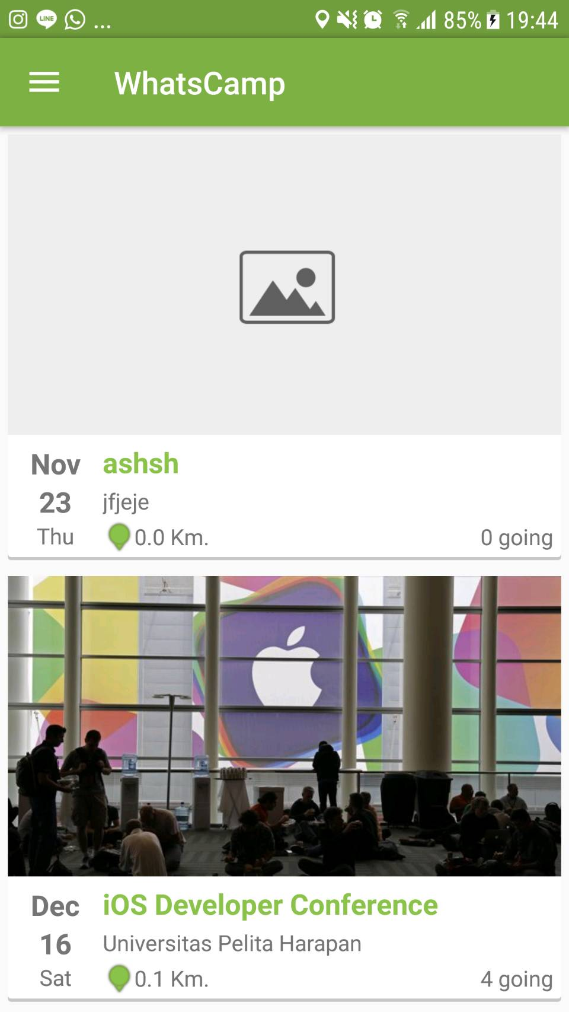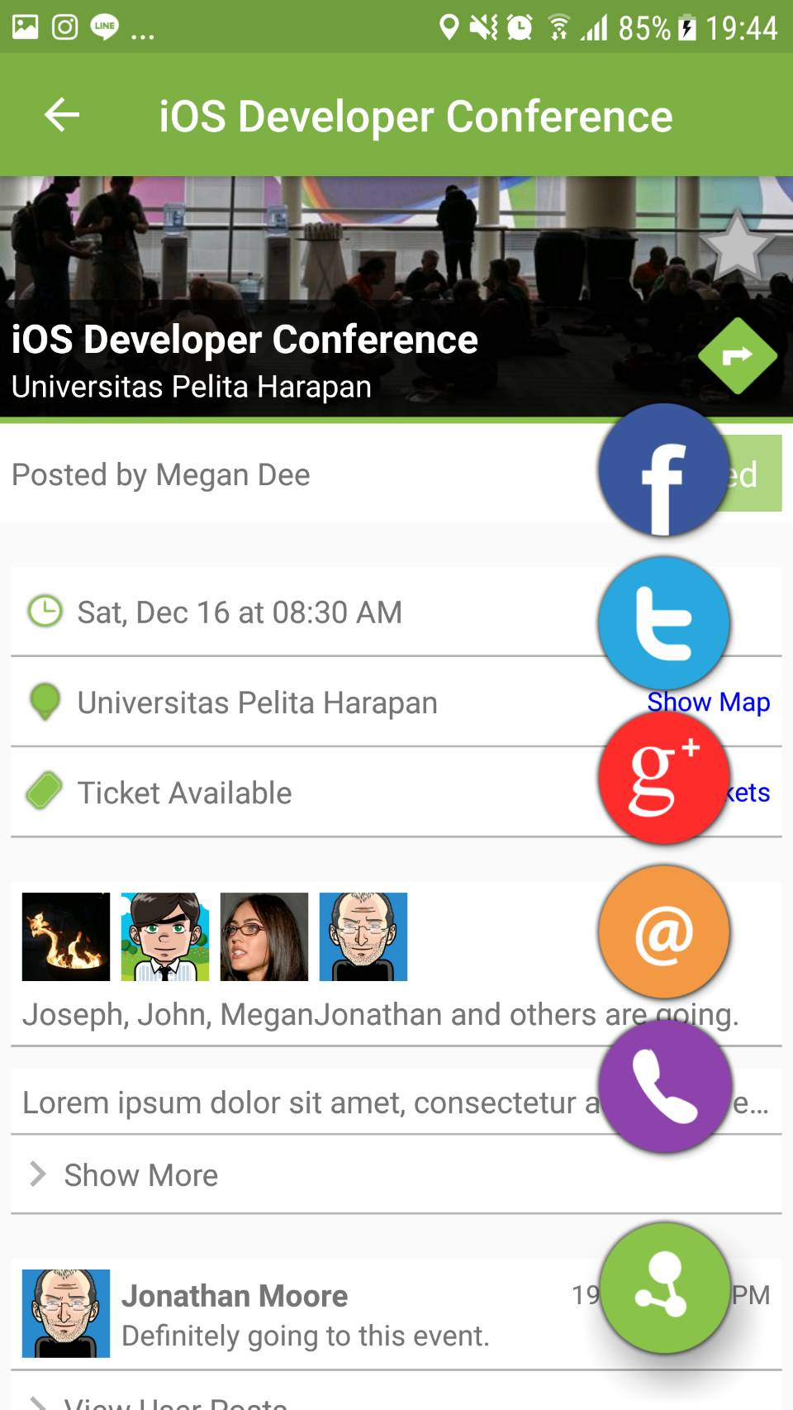[2]

## 

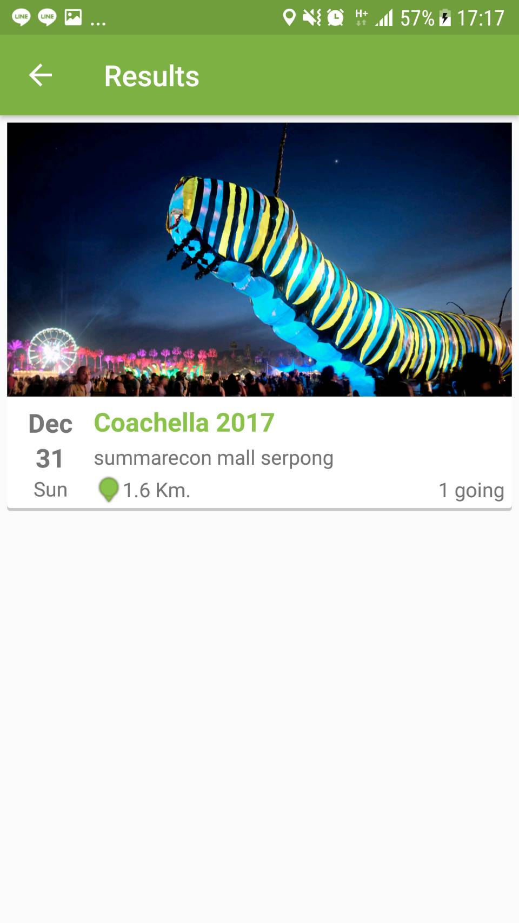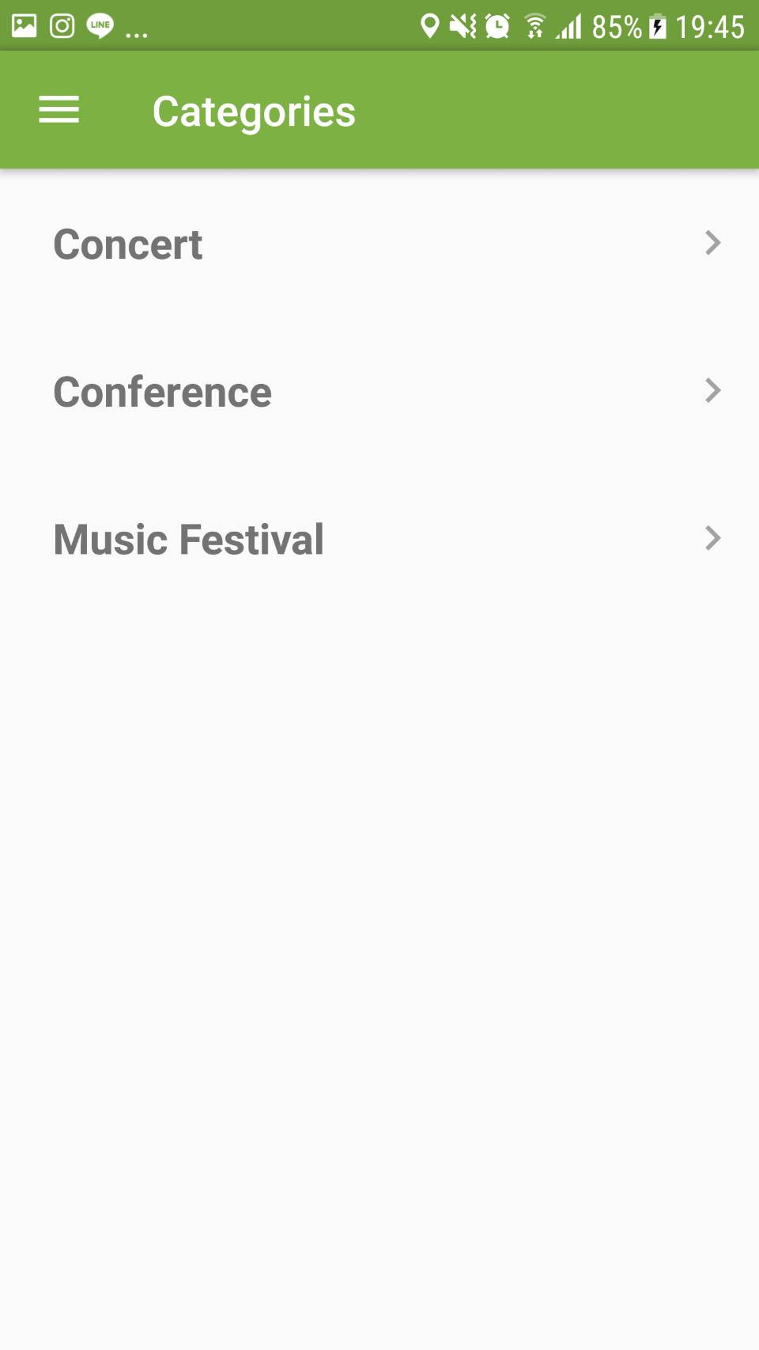

## 

## Descriptions of fields, content

Screenshot in 3.1 shows all the functionalities of View Event. The description for some components are:

1. Events: The events that exist and shown in the main page.
2. View Event: To view the more detailed information about the selected event.
3. Share icon: To share the event to another apps or platforms.

For viewing specific event based on their categories, we can use filter through the menu with:

1. Categories icon: To view categories that filter every event that the criteria fits the categories.

## Description of actions

The possible actions that can be done in this screen are the user will be able to view one of the events, view events through categories, share to another apps or platform, and go to the event.

## Sequence of screens

View event screen will be shown when user selected a event, or when user selected one of the categories and select one of the event that shows after.

# Functionalities 2 : Favourite Event

This feature enables user to favourite event that has happened or will happen so that the user could look back the favourited events which will be shown in the favourite event menu.

## Screenshot

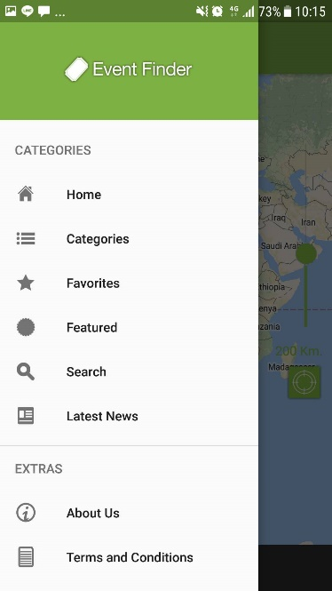[2]

## Descriptions of fields, content

When user view an event, they can click on favourite icon. It will save the event in favourite, so that user can lookafter the selected event at ease without too much searching. The favourited events can be accessed from navigation drawer on the left.

## Description of actions

Actions available are favourite the event, and click the favourite icon on the navigation drawer to look for the favourited event.

## Sequence of screens

User click the star icon on the top of the selected event’s page. To view the favourited events, user click the navigation drawer, and then to view the favourite screen, the user has to select the favourite icon.

# Functionalities 3 : Search Event

This function enables user to search wanted events with a specific keywords, and shows suggestions based on keywords.

## Screenshot

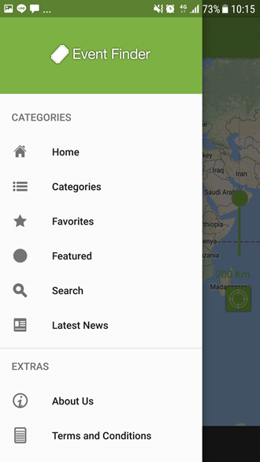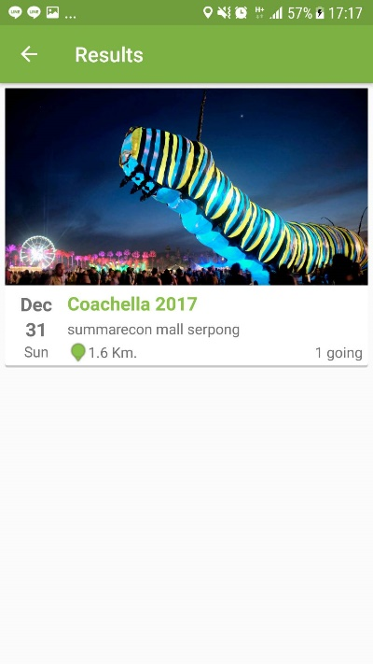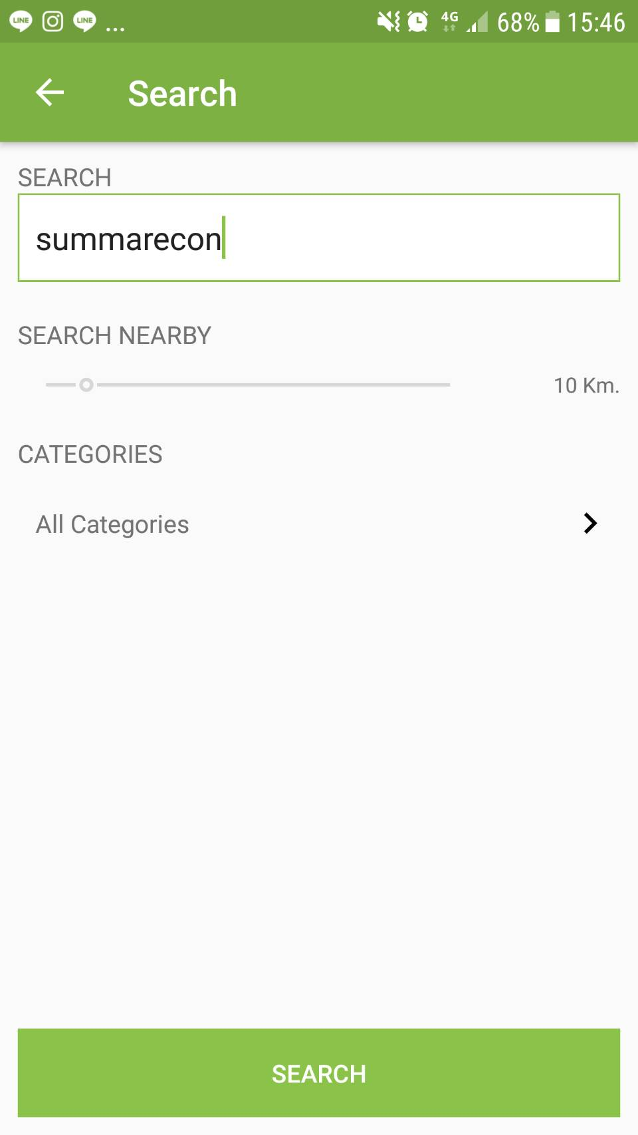[2]

## Description of fields, content

The return results will show events based on search query. All events that contain search query will be shown in the screen. Example in screenshots show that user search for “summarecon” with no specific categories (all categories), when user pressed find in keyboard, the result is given.

## Description of actions

Actions available are search for events, the event’s location to the user’s location, and click the event to view.

## Sequence of screens

User select Search (icon), user input search query, the search results will be shown.

# Functionalities 4 : Going to Event

This function enables user to state that he/she will come to the event, and showing page that shows how many users that will come to the same event. When it almost near the date of the event, it will give reminder about the event.

## Screenshot

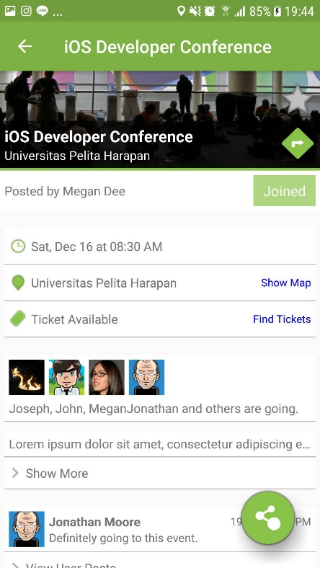[2]

## Description of fields, content

When user view an event, they can click on the join button. It will state that the user will participate and join the event when the event begin.

## Description of actions

Action available is clicking the join button.

## Sequence of screens

On the selected event, user click the join button. Then WhatsCamp will list the user to the list of people going to the event.

# Functionalities 5 : Manage Event(Edit, Delete, and Add Event)

This function enables user to state that he/she will come to the event, and showing page that shows how many users that will come to the same event. When it almost near the date of the event, it will give reminder about the event.

## Screenshot

[2]

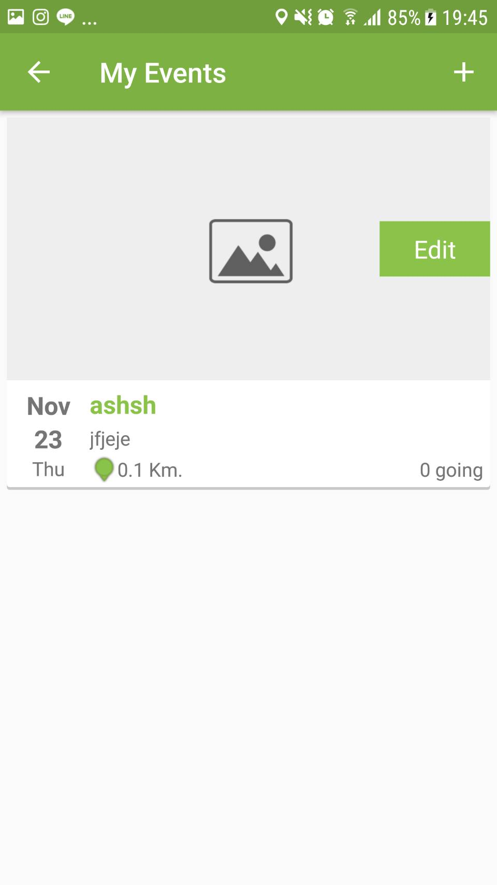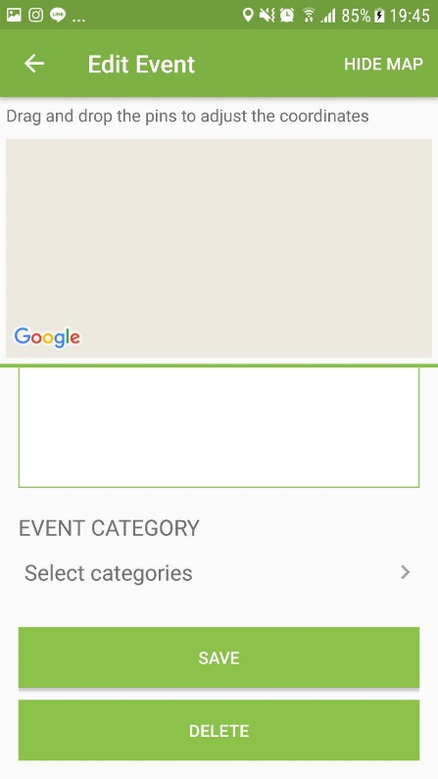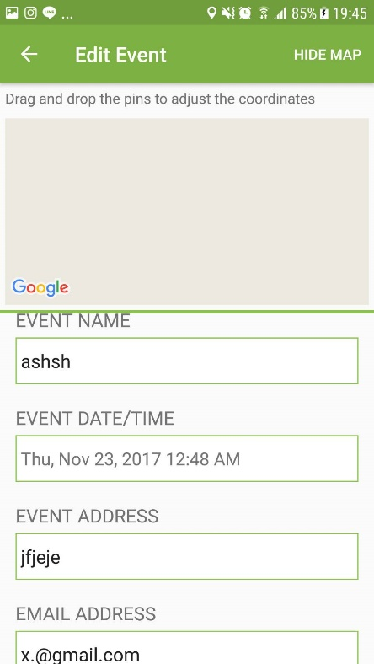

## Description of fields, content

When user want to manage an event, the user can add the event by clicking the + icon, and then insert the details of the event such as the event’s name, location, date/time, etc. The user can also edit an event by clicking the desired event in the My Event’s page, and change the details of the event, and delete the event by clicking the delete event button.

## Description of actions

Possible actions that can be done in this screen are Add Event, Edit Event, and Delete Event.

## Sequence of screens

When user is inside the My Event’s page, the user click the + icon to add the event, or select the event that the user wants to edit, then edit the event’s detail on the Edit Event page. When the user wants to delete the event, the user clicks the delete event button, and then WhatsCamp will delete the event from My Event’s list.

# References

[1] “Free vector icons - SVG, PSD, PNG, EPS &amp; Icon Font - Thousands of free icons.” .

[2] “Event Finder Full Android Application v1.0 » Download Free Premium Scripts, Wordpress Plugins, Mobile Games and Apps.” .

End of document